For this assignment, we will be writing a parser that is able to parse an input file written in our “**Tiny**” grammar. You should finish writing the “**Parser**” class that I’ve provided. Your Parser class should **print**:

* Each time it enters or leaves a rule and what the rule is:  
  *Entering* ***[RULE_NAME]*** *Rule  
  Exiting* ***[RULE_NAME]*** *Rule*There are two exceptions: the **ID** and the **INT** rules. In this grammar, **ID** and **INT** are also Token names, so we will not print when we are “entering” or “exiting” those rules since we can just check the token type.
* Each time it recognizes a token and what the token was:  
  *Found* ***[TOKEN_TYPE]*** *Token:* ***[LEXEME]***For rules with Epsilon definitions, you should also indicate if that definition was chosen:  
  *Did not find* ***[TOKEN_TYPE]*** *or* ***[TOKEN_TYPE]*** *Token, choosing EPSILON production*
* Something, everytime it catches an error:  
  *Expected* ***[TOKEN_TYPE]*** *found* ***[LEXEME]***When the error could have been multiple things, separate the token types with the word **or**  
  *Expected* ***[TOKEN_TYPE]*** *or* ***[TOKEN_TYPE]*** *or* ***[TOKEN_TYPE]*** *found* ***[LEXEME]***
* How many parse errors were found  
  *There were* ***[X]*** *parse errors found.*

**Parser.rb** extends **Scanner.rb** (The lexer that you wrote for your last assignment) and provides a framework for a top-down, recursive-descent parser of the **TINY** language. The parser stays one token ahead in the Token stream **(@lookahead**) and uses the Token to predict how to continue parsing the current instruction and which method to call next.

The **consume()** method calls **nextToken()** in the scanner. The current **@lookahead** Token is discarded, and the next Token in the stream is retrieved. Whitespace Tokens are discarded.

The **match(dtype)** method tries to match the **@lookahead** Token with the provided type (**dtype**). If a match is found, **consume()** is called to retrieve the next Token. Otherwise an error message is displayed and then **consume()** is called to retrieve the next token.

The **program()** method is first called to parse a **TINY** program. Since a **TINY** program consists of a sequence of statements, **program()** calls **statement()** repeatedly until it encounters the **EOF** token.

Complete the parser by providing methods for the appropriate BNF rules in **TINY**.

I have given you my **lexer** and **token** ruby classes. I have also partially written the **parser** for you and have written a **main.rb** file that can run your ruby parser. Your assignment is to **FINISH WRITING THE PARSER** (parser.rb).

I have also included 5 sample input files that you can use to test your program once you’ve finished writing it.

**input[1-3].txt** should complete with no parse errors.

**input[4-5].txt** should have parse errors.

Below are screenshots of what your output should look like, based on the input files I’ve provided.

**input3.txt**

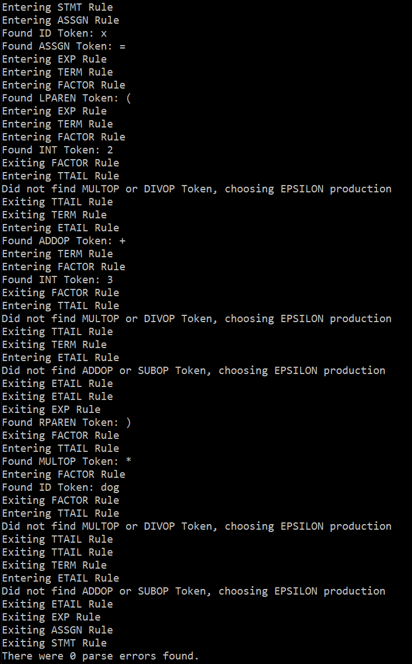

**input4.txt**

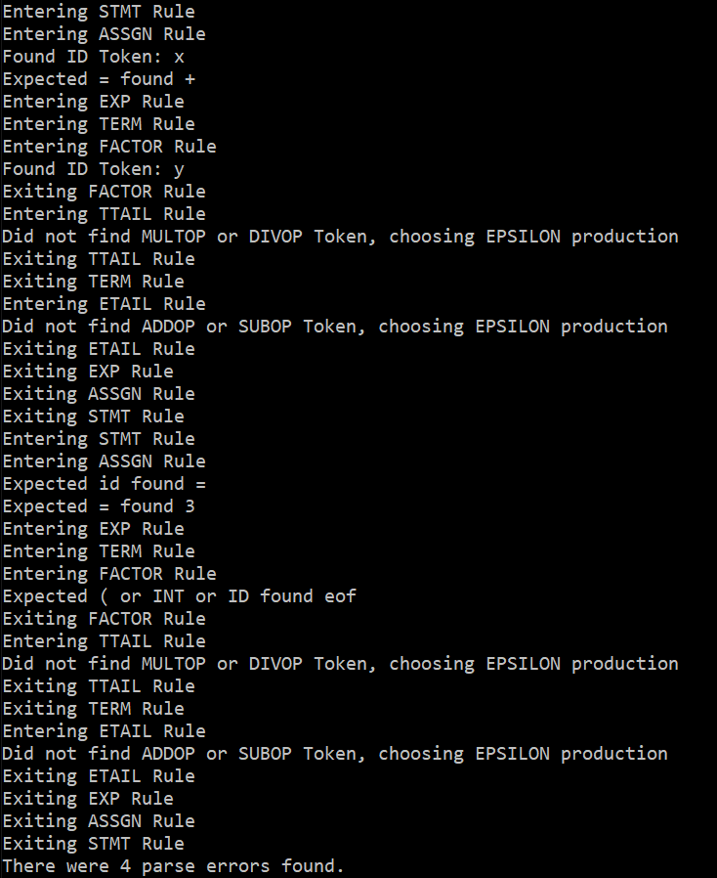

**input5.txt**

